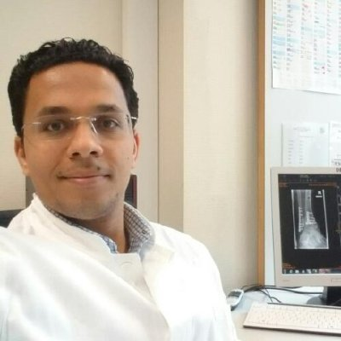
Curriculum vitae
Amr Abo El Fadle El Sayed Mohammed
M.B.B.cH., M.Sc.

Assistant lecturer of orthopaedic and traumatology
Assiut University, Assiut, Egypt
First name: Amr
Family name: Mohammed
Telephone: Home: +2 088 2355644, mobile: +201007788699, +1 412 294 2884
E-mail: amrmortho@gmail.com, amr.a.mohamed@aun.edu.eg
Date of Birth: March 3rd, 1985
Nationality: Egyptian.

Address: 16 Mahmoudrashwan street el sadad region, Assiut, Egypt
Correspondence: Assiut University Hospital, Assiut, Egypt
Languages: Arabic (native language), English (fluently).

August 13, 2013-Present:
Orhtopaedic and traumatology Assistant Lecturer (Assiut University Hospital, Assiut, Egypt)

March 2nd, 2013-August 12, 2013:
Orhtopaedic and traumatology Demonstrator (Assiut University Hospital, Assiut, Egypt)
March 1, 2010-March 1, 2013:
Orhtopaedic and traumatology Resident (Assiut University Hospital, Assiut, Egypt)
M.B.B.cH (September 2007): Faculty of medicine, Assiut University
Excellent with Honor, ranked 6th among 550 students

M.Sc. in Orthopedics and Traumatology (July 2013): Assiut University Hospital
Title: The Use of Polyetheretherketone Cages in single and multiple levels Anterior Cervical Interbody Fusion

Internship (March 2008, March 2009):
One year of training in Assiut University hospitals in the following departments:
- General medicine
- General surgery
- Gynecology and obstetrics
- Pediatrics
- Anesthesia and emergency

Residency:
Three years of residency in Orthopedics and Traumatology (Orthopedics and Traumatology Department) at Assiut University Hospital (the largest hospital in Upper Egypt). The hospital lies in Assiut city and is the main center to which complicated cases are referred (Tertiary Centre) from all governorates in Upper Egypt comprising around 30 million people. Moreover, this hospital is responsible for teaching and provision of research facilities. It includes inpatient wards and outpatient clinics in all medical specialties.

Assistant lecturer and specialist in Orthopedics and Traumatology (Assiut University, August 2013-Present):

During this period, I gained more experience in trauma and general orthopedic

SICOT fellowship in Orthopädische Klinik König-Ludwig-Haus Würzburg Germany

Six months fellowship from mid February to mid August 2015, Joined Oberarzt Dr. Matthias Walcher as an observer in multiple foot and ankle surgeries
An observer fellowship in Schön Klinik München Harlaching Germany under the supervision of Prof. Dr. Markus Walther for two months (May – June ) 2016
Four months research fellow in Allegheny General Hospital biomechanical Lab under the supervision of Professor Mark Carl Miller from December 2017 to March 2018

Undergraduate teaching (Orthopedic and traumatology Department, AssiutUniversity, Sep. 2013-Present):
“spine Examination, Spine imaging, General instruments, upper limb trauma, Etc…”

AO Trauma Principle course , Cairo , June , 2012

AO Degenerative Spine Course,Cairo,Sep.2012

Teaching programs:
The following training programs that were organized by the faculty and leadership development project (FLDP) in Assiut University:
- Conference Organization
- Student Evaluation
- Effective presentation
- New trends in teaching
- Research Team Management

Professor Galal Zaki Said:
Faculty of medicine ,Assiut university ,Emertius Professor of Orthopedic and Traumatology . National Delegate of SICOT/SIROT for the Middle East, Former AO Middle East trustee . Orthopedic department Assiut University , Assiut 71516, P.O. Box 110 , Egypt
E-mail: gzsaid@yahoo.com
Professor Osama Farouk
Faculty of medicine ,Assiut university ,Professor of Orthopedic and Traumatology . Orthopedic department Assiut University , Assiut 71516, P.O. Box 110 , Egypt
E-mail: osama_farouk@yahoo.com

